**Lesson 2 Demo 2**

**Setting up Ansible with Docker**

**Objective:** To install and set up Ansible using Docker

**Prerequisites:** None

**Tools required:** Ubuntu terminal

**Steps to be followed:**

1. Installing Docker
2. Creating the Dockerfile to install Ansible
3. Building the Docker image
4. Running Ansible on Docker

**Step 1: Installing Docker**

1. Run the following commands to install Docker on Ubuntu:

***sudo apt-get update***

***sudo apt install docker.io -y***

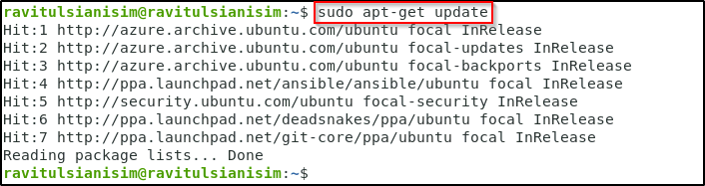

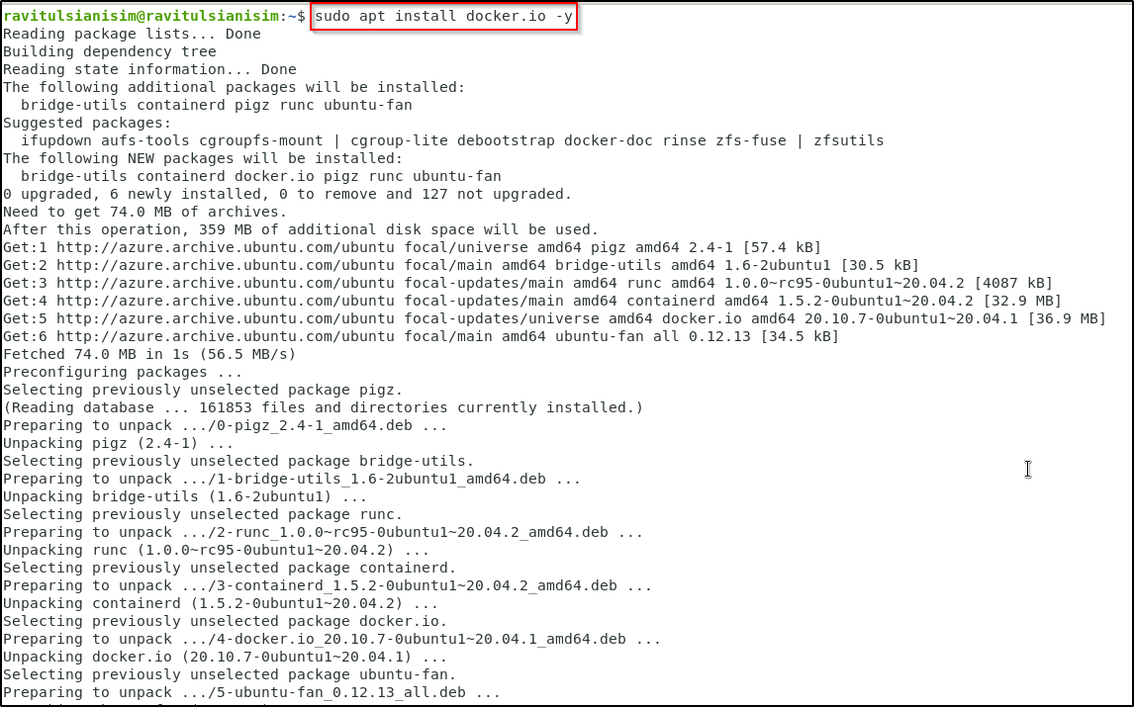

1. Use the following command to verify that Docker has been installed properly and to check the version:

***docker --version***

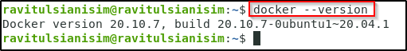

**Step 2: Creating the Dockerfile to install Ansible**

1. Create a Dockerfile that has instructions to run Ansible. You need to create a file named *Dockerfile* in your home directory using the below command:

***vi Dockerfile***



1. Add the below code to the Dockerfile

***FROM ubuntu:20.04***

***ENV ANSIBLE_VERSION 2.9.17***

***RUN apt-get update; \***

***apt-get install -y gcc python3; \***

***apt-get install -y python3-pip; \***

***apt-get clean all***

***RUN pip3 install --upgrade pip; \***

***pip3 install "ansible==${ANSIBLE_VERSION}"; \***

***pip3 install ansible***

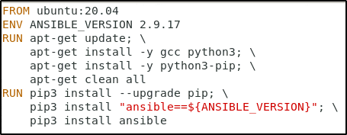

**Step 3: Building the Docker image**

1. Run the following command to give permissions:

***sudo chmod 777 /var/run/docker.sock***

1. To build the Docker image using the directives found in your Docker file, use the following syntax. Don't overlook the trailing period.

***docker build -t ansible:latest .***

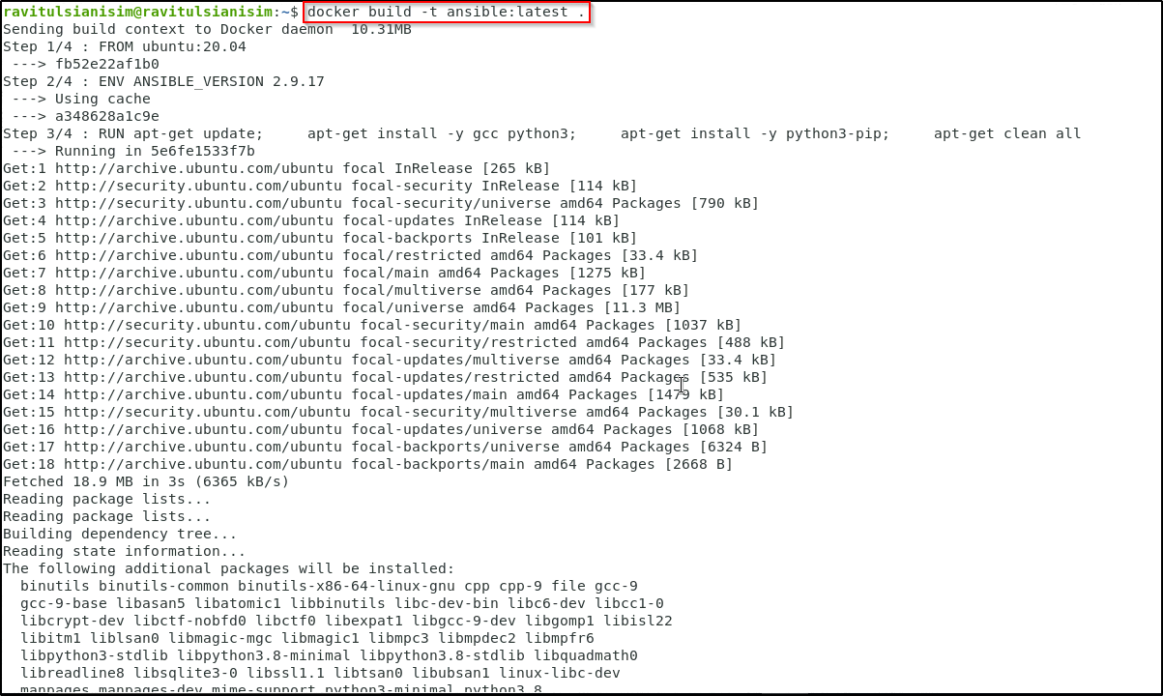

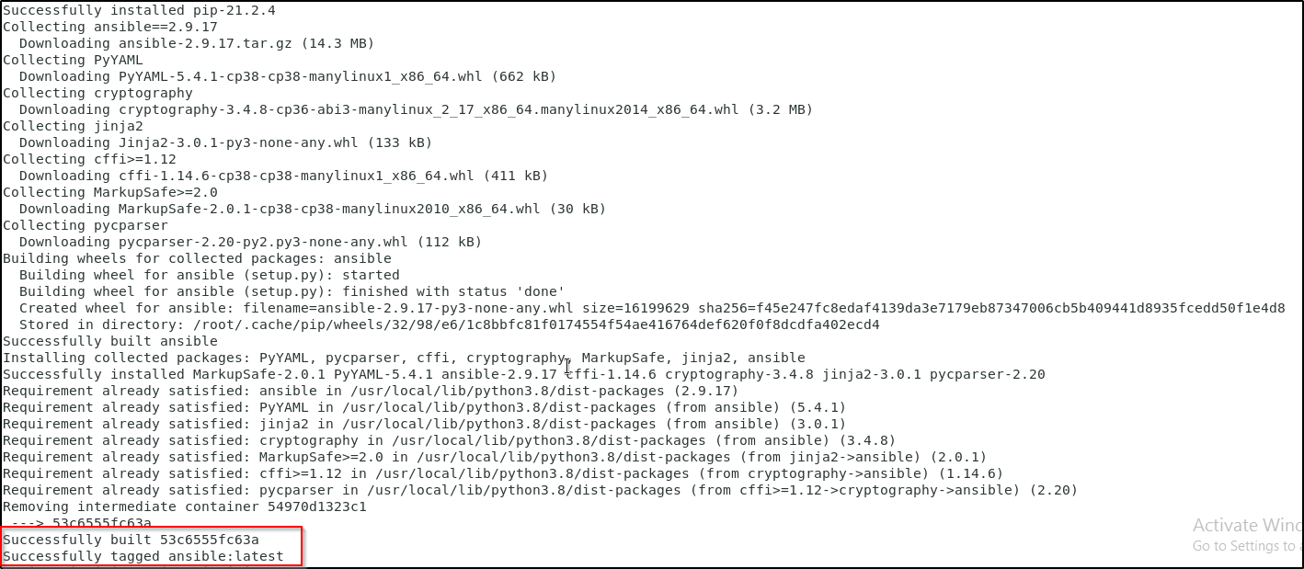

**Step 4: Running Ansible on Docker**

1. Use the following command to run the newly built Docker image containing Ansible in interactive mode

***docker run -it ansible***

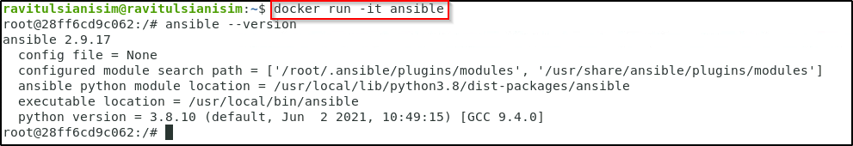

1. Inside the container, run the command ***ansible --version*** to check the ansible version. You can type ***exit*** command to stop the container.
2. Thus, you have set up Ansible on Docker successfully.